Abstract
This paper draws on and extends recent conceptual work on ‘attachment’. I do so to call for an energy geography that attends to people’s affective relations with high carbon promissory objects. My argument emerges from an empirical study of pro-coal sentiment in Whitehaven, an English town at the centre of global political controversy because of a plan to open a coal mine in the area. Showing that pro-mine persuasions in the area are underpinned by a process of ‘re-attaching’ to coal, I argue that the case of the Whitehaven mine is a warning about how fossil fuels can re-emerge as promissory objects even when a transition away from fossil fuels has been completed. Drawing implications for wider geographical studies about emotions and affects in energy transitions, I conclude by calling for further research on the way attachments to high and low-carbon objects are (re/de) composed, an urgent task given the need for rapid societal decarbonisation – one which has received very little attention to date.

1. Introduction
This paper examines pro-coal politics in Whitehaven. A remote northern English town, Whitehaven is a place which is not accustomed to being at the centre of political controversy. But in 2017, when it was revealed that an Australian company planned to open a coal mine in the area, this changed rapidly (Kalshoven 2022b). To the consternation of local elected representatives who backed plans for the mine and wanted to see it open without delay, national political actors intervened, pointing out that a decision over the mine’s future was not a local matter but one of national import. Moreover, they argued that plans for the mine should be rejected, for giving it approval risked damaging the UK’s international reputation as a climate leader (Willis, 2024). This put in motion a prolonged political and legal battle over whether the mine should be granted approval, culminating in the UK Government giving it the green light in December 2022.
The political dynamics surrounding the Whitehaven mine and why it was eventually given approval (despite the climatic consequences of doing so) warrant attention (Willis, 2024). However, in this paper my focus is not on Whitehaven per se. Rather, I attend to pro-coal sentiment in the town to ask what challenges the emergence of pro-coal politics in Whitehaven might portend for attempts to build a world without fossil fuel dependency. Drawing on recent geographical theory about ‘attachment’ (Anderson, 2022), I make the case that the question of the Whitehaven mine illustrates the need to attend to the (de/re) composition of attachments to high carbon objects in energy geography, an issue which has received little conceptual and empirical focus to date.
To begin to understand my argument, we must consider Whitehaven’s history. Like other post-industrial areas in the UK, mining activity in Whitehaven came to an end in the 1980s. But in contrast to other parts of the country, the end of pit activity in Whitehaven did not lead to widespread social deprivation. Mine closures dovetailed the arrival of a new major employer to the area, the nuclear industry (Davies, 2012). The industry came to pay a generous wage to the many thousands of people it now employs, making the area unusually wealthy given its location in the north of England (Oxford Economics, 2017). The significance of the transition from coal to nuclear for locals crystallised for me whilst I was walking along Whitehaven harbour with one of my informants whilst conducting fieldwork in the area. Sheila is a young project manager who until recently had worked for the nuclear industry. We were discussing the legacy of UK Prime Minister Margaret Thatcher for ex-coal communities in the UK.
“I remember as a child, and my grandma still says it now, don't mention that name in our house...See, I think it was probably the large-scale impact [her actions were] having. But it's a hard one because even though we've got really deep mining roots, they do seem quite different to the likes of County Durham [another ex-mining community]. We seem to kind of – not be forgetting about it, but slightly moving on”.
Coal: ‘Not forgetting about it, but slightly moving on’. But the reason Sheila and I had met was to discuss support for the controversial new mine, a plan which ostensibly aroused passionate pro-coal sentiment among many locals. If residents had ‘moved on’ from mining, why were many of them supportive of plans for the new mine?
This tension animates the pages that follow. I structure my paper in five parts. First, I begin by outlining recent conceptual work on attachment (section 2) before briefly describing my case study and research methods (section 3). I then examine how re-attaching to coal occurs in Whitehaven (section 4) and draw attention to my paper’s broader implications for energy geographers and other social scientists (sections 5 and 6).

2. Coal attachments

Coal as emotion and affect
Support for new coal extraction is often high in communities with intimate experiences of mining (Della Bosca and Gillespie, 2018; Herrero and Lemkow, 2015; Svobodova et al., 2021). In a study of a rural Australian community, Hannah Della Bosca and Josephine Gillespie (2018) document how plans to expand an existing coal mine is supported by residents for the way coal is folded into the town’s sense of self-identity. The value of coal is “more-than-economic” (2018: 738), they write, and is integral to “the emotionality of people-place connection” (2018: 738). A similar study is Amaranta Herrero and Louis Lemkow’s (2015) analysis of resistance to mine closures in Spain. Herrero and Lemkow reveal a gendered dynamic, one where the “figure of the miner as a working class, hypermasculine ‘tough guy’” (2015: 230) informs desires to keep coal mines open.
Ethnographers of post-mining UK communities have undertaken comparable studies (Bright, 2012; Rohse et al., 2020; Walker, 2020; Walkerdine, 2010). In these examples, the concept of ‘affect’ is often preferred over ‘emotion’ for the way it attends to moods which circulate and linger in social spaces, creating pre-cognitive dispositions and shared feelings among social groups (Rohse, Day and Llewellyn 2020). Studies like Geoffrey Bright’s (2012) show that even though mining is no longer operational in his location of study (rural Derbyshire), coal retains affective value for the way it continues to shape people’s sense of self, place, and classed identities. Coal exists as ‘afterlife’ and has a strange present-absent dynamic – it shapes people’s dispositions whilst the source of these affects (extractive activity) no longer exists. Coal affects are described as haunting the communities they circulate among; they are “ghosts” (2012: 319) which linger from a lost past.

Coal as promissory object
I would like to suggest reading these studies by drawing on Ben Anderson’s (2022) recent work on ‘attachment’. Inspired by cultural theorist Lauren Berlant, Anderson is interested in certain types of subject-object relations, namely those where specific objects “come to feel necessary to a way of life” (2022: 1). As opposed to other types of relations (i.e., connections, associations), attachments are defined by the way the thing that the subject becomes bound to is felt as “a promissory object” (2022: 1), one “that…opens a valued future – whether of continuity from the present, or return to a lost past, or of something better” (2022: 9). As Anderson explains, people can and do become attached to a myriad of things: to “Gods, Brexit, lost hopes, how another person laughs…land, whiteness, nation, a phrase” (2022: 2). Moreover, attachments are not necessarily straightforwardly positive but can “simultaneously sustain and harm” (2022: 3). In other words, people bind themselves to objects which wound them, even whilst these same objects simultaneously provide affective grounding to move through disorienting worlds (Berlant, 2011).
Reading the above case studies through this lens, coal is foregrounded as a promissory object. Herrero and Lemkow’s (2015) miners rise to defend the mines when the government threatens to close them because of the affective ties coal provides for constructions of masculinity. Geoffrey Bright’s (2012) communities are attached to coal because it harks back to a time when the mines organised a way of life around them. Indeed, it is worth underscoring the temporal rhythms of these attachments. In Herrero and Lemkow’s (2015) case study, when the object in question is threatened, attachments to it expand and intensify, igniting impassioned feelings which translate into confrontational forms of political action. In Bright’s ethnography (2012), coal attachments are of a different nature: They are more subdued and appear to be gradually diminishing over time. Further, just as attachments can wane over time, such that processes of detaching unfold, processes of re-attaching can occur when an object which appeared to no longer be important re-appears as something which once more signals a valued future. Understood in this light, attachments scramble otherwise comforting notions of linear time, moving in sometimes unpredictable, erratic ways. As I will show in sections 5 and 6 and in relation to my case study, this helps remind energy geographers of the non-linear nature of net zero energy transitions.
A comparable analysis which uses the lens of ‘attachment’ might be carried out for Della Bosca and Gillespie’s (2018) aforementioned study. In fact, Della Bosca and Gillespie (2018) use ‘place attachment’ in their analysis, a concept which emerges from social psychology and refers “to the ecological, built, social, and symbolic (Hummon, 1992, p.253) bond between individuals and the place they live” (2018: 736). However, this is different to Anderson’s (2022) ontological use of the term. I suggest that inserting Anderson’s specific use of ‘attachment’ into energy geography helps us move beyond a focus on place per se towards, foregrounding the way promissory objects can operate in ways that move across multiple spatial sites and scales, including individual bodies; in people’s homes; and in mobile sites that travel across spaces (see section 6). With this appreciation in mind, I now detail my case study.

3. Case study and research method
Located on the west of Cumbria, the town of Whitehaven is home to a population of 23,000 residents (City Population, 2023). From the seventeenth to the twentieth century, fossil fuel industries including coal mining shaped the contours of local economic activity (Chapman, 1993; Davies, 2012; Whitehaven Town Council, 2023). Further, coal pits and other industry shaped gendered and classed relations, and moulded people’s sense of identity. In the twentieth century, coal-based industry steadily declined, with the last of the mines closing in 1986 (Whitehaven Town Council, 2023).
As mentioned, Whitehaven is unusual for a UK post-industrial area in that it bucked an otherwise widespread trend in other parts of the UK where coal mining ended. The arrival of the nuclear industry in west Cumbria in the 1950s and its growth over the following decades meant that many workers who lost work in the coal industry were able to transition to work in nuclear (Davies, 2012). By the turn of the twenty-first century, almost all industry other than nuclear had disappeared. The nuclear operator is now called Sellafield and employs more than 10,000 people (Oxford Economics, 2017). Sellafield provides a handsome wage to many. But it is the only major employer with well-paid, secure jobs in the area. Some argue that there is a sense of ‘dependency’ on nuclear in the area (Wynne and Waterton, 2007)
Whilst in the field, I was animated by a desire to probe the nuances of people-coal relations. I wanted to understand how people ‘thought-felt’ (Ingraham, 2023) coal as an object given its ambivalent status. On the one hand, coal is imbued with emotional weight given its historic importance. On the other hand, its allure has dimmed in recent decades due to the social traumas inflicted by industrial demise and because of public recognition that coal has played a significant role in causing climate change. I used interview and ethnographic methods, allowing myself to be oriented by these questions as animating issues. Many of those I chose for interview were actively involved in local debate about the mine. I used a purposive sample so that interviewees were broadly demographically representative of the area by gender and age (see appendix 1). Thirty-nine long conversations were held in total, the majority over the course of five weeks in October and November 2022. I now turn to sharing my research findings.

4. Re-attaching to coal

Coal as afterlife
Even though four decades have passed since Whitehaven’s mines closed, coal continues to shape the town’s milieu in two ways.
First, it persists in the materiality of the town. The harbour, once a hub of bustling industrial activity, has been regenerated into a site for leisure purposes, mainly as a place to moor sailing boats. But vestiges of mining are still visible. This includes a large ventilation shaft and memorials to pit workers which recount evocative stories about the area’s coal past. Texts accompanying statues of pit workers speak of “the end of an era” and describe past times as a period when “there w[ere]…mines, steelworks, nobody had any problems with jobs, they just hadn’t” (Figure 1). Dotted elsewhere are numerous other mining relics, the largest of which is Hague Pit, an impressive building with an enormous mining wheel attached to it (Figure 2).
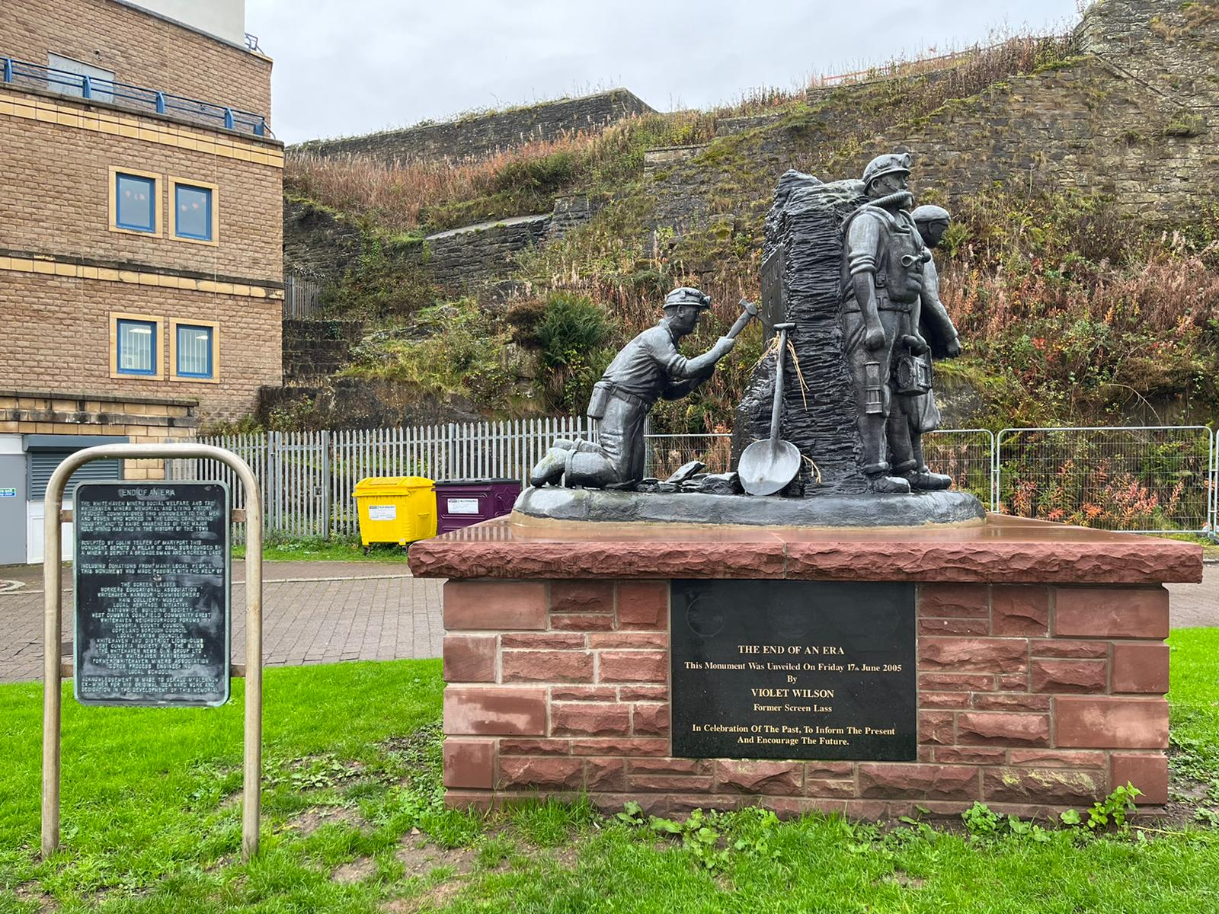
Figure 1
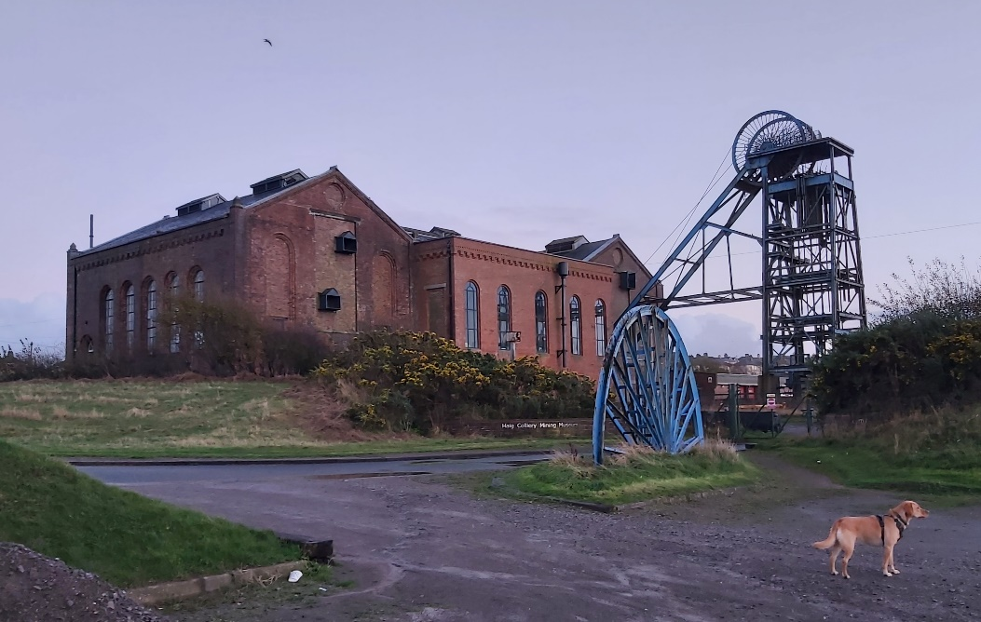
Figure 2
Second, coal continues to shape Whitehaven’s milieu in the way it informs contemporary ideas of community identity. This is most pronounced among older generations who have a personal memory of mining. In their accounts, coal interweaves with kinship relations, evoking memories of intimate relations bound up with industrial activity.
“My dad, he worked in [one of the biggest local pits]. He were down the mine for 30, 39 years, something like that…Obviously coal mining is a big thing around here. We’ve got history in coal.” (male, 60s, ex-nuclear union official)
The meaning of prior coal activity for younger people who do not have a personal memory of mining is less clear. The young people I spoke to see coal as an important part of the area’s heritage, but not closely tied to their personal identity.

Detaching from coal
Mining activity thus exists as material and relational afterlife in Whitehaven. But an afterlife is more akin to residue than an object of future-oriented promise. Indeed, following the end of mining in the 1980s, communities in Whitehaven came to see themselves as predominantly defined through a nuclear identity, rather than their coal heritage (cf. parallels with Kalshoven 2022b).
“[The] nuclear industry has probably taken over from where coal had been previously. So, in the same principle that you grew up as a mining community, you grow up as a nuclear community and work in the same industry.” (female, 40s, public relations professional)
Many came to see the nuclear industry and its economic benefits as a source of optimism. In an area that is inexpensive, a good monthly wage promised to provide ample opportunity for nuclear employees to access material goods. It also offered rewarding careers for those able to access them.
“The wages up in West Cumbria are pretty good in the nuclear sector, but the housing prices have remained really cheap…It's always been a good place to live…you see young 20-year-olds driving around in BMWs and Mercedes.” (male, 60s, Sellafield administration)
In these descriptions, objects of attachment emerge (flashy cars, homeownership, a career) which the promise of working in Sellafield clusters around. What is noticeable is the absence of coal as an aspirational object. It has been relegated to occupying a backdrop which no longer seems to be affectively potent.
But, as discussed earlier, even when subjects appear to detach, affective ties can linger. ‘Afterlife’ should thus be read as a descriptor indicating a process of distancing such that the affective potency of the object loses much of its strength, rather than as indicating full detachment which would imply closure. Afterlives could be understood, then, as containers which carry within them an object with the potential for reignition, such that that object might once again signal a promise.

Re-attaching to coal
When plans for the mine became public, some of my interviewees began a curious process of reattaching to coal. Most stressed the new employment opportunities that the mine promises to deliver (Kalshoven, 2022a) and emphasised a sense of cultural familiarity with the types of jobs the mine is expected to provide.
Others argued that anxieties about Sellafield underpin support for the mine. A theme that came up frequently was a feeling that the local population relies too much on Sellafield for work.
“I think we’re over reliant on nuclear. We’re far too reliant on it. We’re so over reliant on it that people are getting desperate for a coal mine.” (male, 30s, Sellafield administration)
Worries about dependency related to existential concerns. Last year the plant entered full decommissioning. Although this will take more than a hundred years (Subramanian, 2022), some were concerned that nuclear jobs would be lost in the years to come and that, without other industry to replace nuclear, there would be little left to support local people.
“I do worry that there won’t be anything to fill the gap when Sellafield eventually closes. We don’t want it to be left as a ghost town.” (female, 20s, Sellafield administration)
Some spoke about pride in the area given Whitehaven’s history as a hub of diverse industrial activity. One interviewee painted vivid pictures of a vibrant Whitehaven which was during the industrial revolution a centre of global innovation.
“[Whitehaven] was the Silicon Valley of the day. [We had] cutting edge technology…that was driving the industrial revolution.” (male, 60s, Sellafield administration)
Another interviewee said he was a “big supporter of the mine” because of the area’s rich industrial history when “mining was a big thing”. This chimed with the views of some young people I spoke to.
“Coal mines and stuff are like the only things to really kick us back up and make us a known spot.” (female, 18-19, youth worker)
“Once we get a coal mine that means more money coming into town which means more shops, which means more people wanna move in and start growing their businesses. At least then there’s hope.” (male, 18-19, youth worker)

Thus, my interviewees described a sense of hope for the possibilities afforded by the mine. However, many simultaneously communicated awareness of the environmental damage that opening a new coal mine would contribute to. Some drew on apocalyptic imagery to describe threats which they saw the mine as hastening, including “water rising because of ice melting” and the different ways climate change is “ruining us faster and faster”. One described his fears of climate change as a spectral future which haunts the present:

“It’s like a ghost. Nobody gives it attention until it destroys stuff that we love…I’ve read that the Maldives could be submerged within the next ten years, if we keep on doing what we’re doing. It’s horrible.” (male, 18-19 youth worker)

For these young people attaching to the coal mine, thus, not only generated hope but also profound unease. They were not alone in communicating climate change concerns. All my informants, including those who were passionately pro-mine, expressed varying degrees of worry about the consequences of climate change for the planet. They understood that fossil fuels were causing climate change, but nonetheless saw the mine as important for its promise of regenerating the area and providing diversity of employment options. Fossil fuel attachments thus threw up simultaneous hope and anxiety, unsettling “the line between sustaining/flourishing and harming/damaging” (Anderson 2022: 3).

5. Fossil fuels as objects of stability in uncertain times
What are we to make of people re-attaching to coal in Whitehaven? As discussed, energy geographers have shown that communities with intimate experiences of extractive industries can feel a sense of cultural-emotional connection with fossil fuels (e.g., Della Bosca and Gillespie, 2018; Rohse et al., 2020). Coal and the material-cultural worlds that it has constituted are central to many communities’ senses of place in the world (Boyer 2023). But what is unique about the case of the Whitehaven mine is the way it shows how attachments to coal which had previously been loosened can be brought back to life many decades later. It is worth dwelling on the significance of the nature of this unforeseen process.
To help me do this, I turn to cultural theorist Lauren Berlant. Perhaps more perspicaciously than any other theorist, Berlant (2011) explores the affective consequences of the wearing down of people’s agency under neoliberal conditions. They write about how the promise of the ‘good life’ in Euro-American political programmes in the post-war years has been undermined in recent decades. Berlant suggests that a strange thing has occurred. Even whilst the conditions required to enact the promises of liberal democratic meritocracy have diminished, attachments to meritocratic narratives have persisted. For Berlant, this is a form of ‘cruel optimism’, the act of desiring something that is “actually an obstacle to your flourishing” (2011: 1) – for, in continuing to desire meritocratic fantasies, individuals make themselves responsible for a failure to enact them, rather than construing alternative narratives which challenge the premise of liberal narratives (Berlant, 2019). In addition, Berlant points to the way conditions of precarity and trauma provide the very fuel for the persistence of these damaging attachments (Berlant, 2011).
This suggests that at times of uncertainty subjects will reach out to historic or contemporary promissory objects to help counteract the disorienting effects of insecurity, even whilst those attachments may generate a deepening sense of dislocation. Berlant’s observation could portend a troubling warning for the future of climate politics. Given that climate instability is likely to lead to deeper and more profound traumas, it is possible that coal and other fossil fuels – the very things which cause climate change – could increasingly become the very objects which some reach out to as a means of gaining orientation in a disorienting world. Given this, perhaps it would not be surprising if we see the resurrection of attachments which rebind people to high-carbon forms of living in the years to come – renewed support for extractive industries, heightened attachment to high-carbon transport, etc, even whilst progress is made in forging attachments to objects which enable more sustainable ways of living (e.g., reduced energy consumption patterns, an increase in renewable forms of energy, etc).
Researchers have pointed to contexts where similar processes may already be occurring. Energy scholar Cara Daggett’s (2018) work on ‘petromasculinities’ examines how affective ties to fossil fuels are bound up with constructions of toxic masculinity in reactionary political movements, in the USA and elsewhere. Her work shows how, under conditions of uncertainty about the future, petromasculinities provide a guiding orientation to groups attracted to authoritarian politics. Governance researcher James Patterson (2023) points to similar dynamics. Whilst Patterson’s and Daggett’s research does not necessarily signal a process of reattaching insofar as they heighten already existing attachments, both warn about the way objects which emerge in unexpected circumstances can undermine attempts to turn away from fossil fuels towards alternative energy sources. The challenge then is to assemble a politics of promise which channels people’s need for attachments towards ends which are compatible with stabilising climatic conditions. The focus should in part be about helping people detach from fossil fuels and other objects which lock society into high-carbon trajectories and also to pre-empt (pre)emergent high-carbon attachments. I suggest that this is a pertinent and fertile area for future geographical research, which I expand on below.

6. Future research trajectories
How do we disassemble attachments to high-carbon objects? These questions have received very little explicit attention. In part this is because the concept of attachment has only recently been elaborated in geography (Anderson, 2022) and not yet entered the field of energy geography. Where attachment has been used to describe human-carbon relations, the term surfaces fleetingly without conceptual elaboration (e.g., Daggett, 2018; Furnaro, 2021).
One approach to explore this question is to build on work by Harriet Bulkeley, Matthew Paterson, and Johannes Stripple (2016) which examines devices, desires, and dissent – “the materialities, subjectivities and resistances through which power and everyday life are organized” (2016: 9) – and their role in enabling net zero social arrangements. Researchers might pay attention to attachments in different spheres of geographical life most relevant to the net zero transition, such as home heating (Lovell, 2016), travel (Bartling, 2016), and consumption practices (Rice, 2016). In so doing, consideration should be given to the reasons why, and the mechanisms by which, certain devices come to be experienced as promissory over others. Further, attending to different sites and scales helps orient attention to the nuanced and different ways in which attachments are formed. Concretely, attachments to specific forms of home heating (say, gas boilers and the specific form of heating they provide) can be expected to take a different shape to attachments to modes of high-carbon travel (say, SUVs), shaped as they are by different political economic environments and affective repertoires of experience. Viewed as such, ‘attachments’ and ‘promissory objects’ as conceptual tools helps widen our theoretical appreciation beyond constructs of ‘place attachment’ (discussed in section 2) which apply more narrowly to specific sites and spatial scales. It also helps underscore the complexity of these attachments, which persist despite their simultaneously deleterious consequences for wounded subjects (Berlant, 2011).
Yet it is important to draw attention to the way that cultivating attachments to net zero practices faces deep challenges. Enacting a net zero transition means bucking a historical trend that has been in place since the start of the industrial revolution. When new energy sources have been discovered in the past, they have been added to the existing energy mix to meet increasing demand, rather than replacing older energy sources (York and Bell, 2019). There is a need, then to find ways of actively removing high-carbon energy sources, not just to continue to scale sustainable forms of energy. This necessarily involves a profound transformation in people-energy relations – a re-configuration of the hegemonic imaginaries which have powered social and economic change for centuries (Garrigou, 2016). In place of the promise of an infinitely expanding pool of energy – which arguably lies at the heart of the project of modernity (Boyer 2023) – it would appear that a radical new promise needs to be sown, recasting energy not as boundless, but as something to be used with moderation.
A separate challenge concerns the issue this paper has centred on – the risk that high carbon attachments might return or intensify. It is possible to imagine that in future years we might see the rekindling of attachments to high carbon objects, even in contexts where progress has been made in binding people to sustainable ways of living. One might imagine a scenario where there has been global progress in significantly scaling up low-carbon technologies and rapidly scaling-down fossil fuel extraction, such that real cuts in global carbon emissions are being achieved. In this scenario it might only take a few unfortunate events for that consensus to unravel, and for a successful counter-hegemonic project wedded to petromasculinities and fossil fuel expansion to re-emerge. To use the typology employed by theorists Geoffrey Mann and Joel Wainwright, this would represent a resurgence of a ‘Climate Behemoth’, a politics “animated by a chauvinistic capitalist and nationalist politics that denies – until it can only denounce – the threat climate change poses” to national polities (Mann and Wainwright, 2019: 1).
We can turn to this year's US presidential elections to think of a real-world scenario which illustrates this point – although the analogy is imperfect, given that real global emissions cuts are not yet being achieved. In recent months, Donald Trump – the presumed Republican party nominee – has grown more ethnonationalist and fossil fuel friendly in his politics. If he wins, Trump has promised that he will reverse the limited but significant progress that has been achieved by the Biden Administration through the passing of the Inflation Reduction Act (Milman, 2024). He boasts that he will ‘drill, baby, drill’ for new fossil fuel extraction. Even if he loses, this does not mean the end of this form of politics. It will find articulation in the USA and other countries for years to come. The scenarios I paint above are nightmarish. However, it is precisely their dystopian nature which makes the task of attending to attachments in the net zero transition so important. The stakes could barely be higher.

Appendix
Sample of interviewees
Factor | Group | Percentage of area (Copeland) – to the nearest percentage point | Target | Number interviewed
Age | 18-35 | 20% | 5 | 7
 | 35-65 | 51% | 12 | 10
 | 65+ | 29% | 7 | 7
Gender | Male | 50% | 12 | 12
 | Female | 50% | 12 | 12
TOTAL |  |  | 24 | 24

- Census data was used for gender and age (ONS, 2021).
- Roughly half of those interviewed were existing or ex-Sellafield employees, mirroring local employment figures(Oxford Economics, 2017).
- Population data available for Whitehaven is not detailed and robust. Therefore, data for the borough of Copeland was used as a proxy.
- The area is 98% white, so there was no recruitment target for BAME diversity (ONS, 2021).

References
Anderson B (2022) Forms and scenes of attachment: A cultural geography of promises. Dialogues in Human Geography 13(3): 392–409.
Apperley E (2020) The industries and economy of Cumbria. Available at: https://www.cumbriacountyhistory.org.uk/sites/default/files/county-info/the_industries_and_economy_of_cumbria_0.pdf (accessed 29 January 2024).
Ayling J (2017) A Contest for Legitimacy: The Divestment Movement and the Fossil Fuel Industry. Law & Policy 39(4): 349–371.
Bartling H (2016) Culture, Technology, and Transport: Navigating a Path to Low-Carbon Urban Mobilities in the United States. In: Bulkeley H, Paterson M, and Stripple J (eds) Towards a Cultural Politics of Climate Change. Cambridge: Cambridge University Press, pp. 94–109.
Berlant L (2011) Cruel Optimism. Durham and London: Duke University Press.
Berlant L (2019) Why Chasing The Good Life Is Holding Us Back (Ep. 35). Available at: https://news.uchicago.edu/podcasts/big-brains/why-chasing-good-life-holding-us-back-lauren-berlant (accessed 13 September 2023).
Bright G (2012) A Practice of Concrete Utopia? Informal Youth Support and the Possibility of ‘Redemptive Remembering’ in a UK Coal-Mining Area. Power and Education 4(3): 315–326.
Brown B and Spiegel SJ (2019) Coal, climate justice, and the cultural politics of energy transition. Global Environmental Politics 19:2: 149–168.
Boyer D (2023) No more fossils. Minnesota: University of Minnesota Press.
Brown RS (2016) Lobbying, political connectedness and financial performance in the air transportation industry. Journal of Air Transport Management 54. Elsevier Ltd: 61–69.
Bulkeley H, Paterson M and Stripple J (2016) Towards a Cultural Politics of Climate Change: Devices, Desires and Dissent. Cambridge: Cambridge University Press.
Chapman M (1993) Copeland: Cumbria’s Best-Kept Secret. In: Macdonald S (ed) Inside European Identities. Providence, RI: Berg, pp. 194–218.
Chatterton P, Featherstone D and Routledge P (2013) Articulating climate justice in Copenhagen: Antagonism, the commons, and solidarity. Antipode 45(3): 602–620.
Chomsky A and Striffler S (2014) Empire, Labor, and Environment: Coal Mining and Anticapitalist Environmentalism in the Americas. International Labour and Working-Class History 85(85): 194–200.
City Population (2023) Whitehaven, in Cumbria. Available at: https://www.citypopulation.de/en/uk/northwestengland/cumbria/E63000326__whitehaven/ (accessed 13 September 2023).
Daggett C (2018) Petro-masculinity: Fossil fuels and authoritarian desire. Millennium: Journal of International Studies 47(1): 25–44.
Davies H (2012) Sellafield Stories. London: Constable.
Della Bosca H and Gillespie J (2018) The coal story: Generational coal mining communities and strategies of energy transition in Australia. Energy Policy 120(April): 734–740.
Department for Communities and Local Government (2019) Indices of Deprivation: 2019 and 2015. Available at: https://dclgapps.communities.gov.uk/imd/iod_index.html (accessed 13 September 2023).
Donaldson C (2022) Glories of the mine? Big Issue North. Available at: https://www.bigissuenorth.com/comment/2022/12/glories-of-the-mine/ (accessed 13 September 2023).
Dunlap RE and McCright AM (2011) Organised Climate Change Denial. In: Dryzek J, Norgaard R, and Schlosberg D (eds) The Oxford Handbook of Climate Change and Society. Oxford: Oxford University Press, pp. 144–160.
Flyvbjerg B (2006) Five Misunderstandings About Case-Study Research. Qualitative Research Practice: 390–404.
Franta B (2022) Weaponizing economics: Big Oil, economic consultants, and climate policy delay. Environmental Politics 31(4): 555–575.
Furnaro A (2021) The Role of Moral Devaluation in Phasing Out Fossil Fuels: Limits for a Socioecological Fix. Antipode 53(5): 1442–1462.
Garrigou A-S (2016) Talking about the social, cultural, and political aspects of the energy transition with Imre Szeman. Available at: https://medium.com/thebeammagazine/imre-szeman-ddb711a51d8a (accessed 29 January 2024).
Hamilton O, Nyberg D and Bowden V (2023) Elements of power: Material-political entanglements in Australia’s fossil fuel hegemony. Environment and Planning E: Nature and Space: 1–23.
Herrero A and Lemkow L (2015) Environmentally Blind Discourses on Coal Extraction and the Idealization of the Miner in Spain. Capitalism, Nature, Socialism 26(4). Taylor & Francis: 215–235.
Holifield R, Chakraborty J and Walker G (2018) The Routledge Handbook of Environmental Justice. Oxon: Routledge.
Ingraham C (2023) To Affect Theory. Capacious: Journal of Emerging Affect Inquiry 3(1): 1–14.
IEA (2023a) The Oil and Gas Industry in Energy Transitions: Available at: https://www.iea.org/reports/the-oil-and-gas-industry-in-net-zero-transitions (accessed 13 September 2023)
IEA (2023b) Coal 2023: Analysis and forecast to 2026. International Energy Agency. Epub ahead of print 2023. Available at: https://iea.blob.core.windows.net/assets/a72a7ffa-c5f2-4ed8-a2bf-eb035931d95c/Coal_2023.pdf (accessed 13 September 2023)
Jacquet JB, Haggerty JH and Theodori GL (eds) (2021) Energy Impacts: A Multidisciplinary Exploration of North American Energy Development. Louisville, Colorado: University Press of Colorado.
Jenkinson L (2022) Michael Gove invited to Whitehaven ahead of coal mine decision. Times & Star. Available at: https://www.timesandstar.co.uk/news/23130096.michael-gove-invited-whitehaven-ahead-coal-mine-decision/ (accessed 13 September 2023).
Kalshoven PT (2022a) For a familiar future: ‘Jobs’ and ‘net zero’ as performative markers of worldviews in England’s nuclear heartland. Futures 144(September): 103039.
Kalshoven PT (2022b) The Fish Is in the Water and the Water Is in the Fish: Symbiosis in a Nuclear Whale Fall. Cultural Anthropology 37(2): 349–378.
Kojola E (2023) Mining the Heartland: Nature, Place, and Populism on the Iron Range. New York: NYU Press.
Lamb WF, Mattioli G, Levi S, et al. (2020) Discourses of climate delay. Global Sustainability 3: 1–5.
Lohmann L (2008) Carbon trading, climate justice and the production of ignorance: Ten examples. Development 51(3): 359–365.
Lövbrand E, Beck S, Chilvers J, et al. (2015) Who speaks for the future of Earth? How critical social science can extend the conversation on the Anthropocene. Global Environmental Change 32: 211–218.
Lovell H (2016) The Making of a Zero-Carbon Homes. In: Bulkeley H, Paterson M, and Stripple J (eds) Towards a Cultural Politics of Climate Change. Cambridge: Cambridge University Press, p. pp.160-172.
Mann G and Wainwright J (2019) Political Scenarios for Climate Disaster. Available at: https://www.dissentmagazine.org/article/political-scenarios-for-climate-disaster/ (accessed 29 January 2024).
Milman O (2024) Climate crisis ignored by Republicans as Trump vows to ‘drill, baby, drill’. The Guardian. Available at: https://www.theguardian.com/us-news/2024/jan/18/trump-republican-rivals-climate-crisis (accessed 29 January 2024).
Moss J, Berners-Lee M, Freitag C, et al. (2020) A Carbon Baseline for Cumbria. Lancaster. Available at: https://slacc.org.uk/wp-content/uploads/2020/06/Cumbria-Carbon-Baseline-Report-2019-200229-Final.pdf (accessed 13 September 2023)..
ONS (2021) Census 2021. Available at: https://www.ons.gov.uk/ (accessed 13 September 2023).
Oxford Economics (2017) The economic impact of Sellafield Ltd. Available at: https://assets.publishing.service.gov.uk/government/uploads/system/uploads/attachment_data/file/730958/The_economic_impact_of_Sellafield_June_2017_Oxford_economics.pdf (accessed 13 September 2023).
Patterson JJ (2023) Backlash to Climate Policy. Global Environmental Politics 23(1): 68–90.
Rice JL (2016) "The Everyday Choices We Make Matter”: Urban Climate Politics and the Postpolitics of Responsibility and Action. In: Bulkeley H, Paterson M, and Stripple J (eds) Towards a Cultural Politics of Climate Change. Cambridge: Cambridge University Press, pp. 110–126.
Rohse M, Day R and Llewellyn D (2020) Towards an emotional energy geography: Attending to emotions and affects in a former coal mining community in South Wales, UK. Geoforum 110: 136–146.
Ross NJ, Renold E, Holland S, et al. (2009) Moving stories: Using mobile methods to explore the everyday lives of young people in public care. Qualitative Research 9(5): 605–623.
Schlosberg D (2004) Reconceiving environmental justice: Global movements and political theories. Environmental Politics 13(3): 517–540.
Scott R and Bennett E (2015) Branding resources: extractive communities, industrial brandscapes and themed environments. Work, Employment and Society 29(2): 278–294.
SEI, IISD, ODI, E3G, UNEP and S (2021) The production gap. Available at: https://www.sei.org/publications/the-production-gap-report-2021/ (accessed 13 September 2023).
Sky News (2022) First UK coal mine in 30 years wins approval. Available at: https://www.youtube.com/watch?v=Elha0Y8_VXI (accessed 13 September 2023).
Statista Research Department (2023) Coal mining in Russia. Available at: https://www.statista.com/topics/7049/coal-mining-in-russia/#topicOverview (accessed 29 January 2024).
Stoddard I, Anderson K, Capstick S, et al. (2021) Three Decades of Climate Mitigation: Why Haven’t We Bent the Global Emissions Curve? Annual Review of Environment and Resources 46: 653–689.
Subramanian S (2022) Dismantling Sellafield: the epic task of shutting down a nuclear site. The Guardian. Available at: https://www.theguardian.com/environment/2022/dec/15/dismantling-sellafield-epic-task-shutting-down-decomissioned-nuclear-site (accessed 29 January 2024).
Svobodova K, Owen JR and Harris J (2021) The global energy transition and place attachment in coal mining communities: Implications for heavily industrialized landscapes. Energy Research and Social Science 71(October): 101831.
The Australia Institute (2023) Coal Mine Tracker. Available at: https://australiainstitute.org.au/initiative/coal-mine-tracker/ (accessed 29 January 2024).
United Nations (2015) Paris Agreement. Available at: https://unfccc.int/sites/default/files/english_paris_agreement.pdf (accessed 13 September 2023).
Urry J (2014) The Problem of Energy. Theory, Culture & Society 31(5): 3–20.
Walker A (2020) Everyday resonances of industrial pasts: Considering lived and affective memories in ex-coal mining landscapes in a South Wales valley. In: Rhodes II MA, Price WR, and Walker A (eds) Geographies of Post-Industrial Place, Memory, and Heritage. Milton: Taylor & Francis Group, pp. 52–67.
Walkerdine V (2010) Communal Beingness and Affect: An Exploration of Trauma in an Ex-industrial Community. 16(1). Body & Society: 91–116.
West Cumbria Mining (2024) Our Approach to Sustainability. Available at: https://www.westcumbriamining.com/responsibility/ (accessed 29 January 2024).
White L (2023) The coal comeback: Michael Gove could give green light to UK’s first coal mine in decades in new bid to slash dependence on Russian fuel. Mail Online. Available at: https://www.dailymail.co.uk/news/article-10749265/The-coal-comeback-Michael-Gove-greenlight-UKs-coal-decades.html.\ (accessed 13 September 2023)
Whitehaven Town Council (2023) Whitehaven History. Available at: https://www.whitehaventowncouncil.co.uk/whitehaven-history (accessed 13 September 2023).
Willis R (2021) ‘Dig coal to save the climate’: the folly of Cumbria’s plans for a new coal mine. The Guardian. Available at: https://www.theguardian.com/environment/2021/may/27/dig-coal-to-save-the-climate-the-folly-of-cumbrias-plans-for-a-new-coalmine (accessed 13 September 2023).
Willis R (2024) Use of evidence and expertise in UK climate governance: The case of the Cumbrian Coal Mine. UCL Open: Environment 6(1): 0–10.
Wright C, Nyberg D and Bowden V (2021) Beyond the discourse of denial: The reproduction of fossil fuel hegemony in Australia. Energy Research and Social Science 77(November 2020): 102094.
Wynne B and Waterton C (2007) Public Perceptions and the Nuclear Industry in West Cumbria. Available at: https://www.researchgate.net/publication/237457843_Public_Perceptions_and_the_Nuclear_Industry_in_West_Cumbria (accessed 13 September 2023).
York R and Bell SE (2019) Energy transitions or additions?: Why a transition from fossil fuels requires more than the growth of renewable energy. Energy Research and Social Science 51(November 2018). Elsevier: 40–43.

Readers will note that I use the concept of ‘afterlife’ to explain how coal pasts inform the present over other concepts used in energy geography to examine comparable ex-industrial contexts, like the use of ‘nostalgia’ in Erik Kojola’s (2023) study of the Iron Range in the US. This is for two reasons. First, whilst nostalgia is necessarily bound to acts of performative remembering, i.e., how people conjure up the past, afterlife draws attention to the residues of coal pasts and their effect in unearthing certain feelings in people in the present. This includes the materiality of old coal mines, like the abandoned mining vestiges which generate feelings in those passing by them, their ‘ghostly’ qualities (Bright, 2012) rendering the past more affectively indeterminate than the term nostalgia would allow for. Second, whilst nostalgia explicitly foregrounds romanticised notions of the past which minimise negative aspects, afterlife does not wed itself to a positive relation with the past – afterlife can connote nostalgic and negative feelings. Afterlife thus mirrors the way I use the concept of ‘attachment’, which underscores the simultaneously sustaining and disorienting nature of promissory objects.
In their writing, Berlant used the pronoun ‘they’.

